Summary & Insights
- Age and BMI: differ the most between diabetic-positive and diabetic-negative groups. Positive patients tend to be older and have higher BMI.
- Z-Test (BMI): The sample mean BMI significantly differs from 25 → deviation from standard BMI observed.
- T-Test (Age): Average age of diabetic-positive patients is significantly higher than diabetic-negative patients → older age is associated with diabetes.
- Chi-Square Test (Smoking History): No significant association between smoking history and diabetes status → lifestyle factor not strongly linked in this dataset.
- Glucose and HbA1c also show moderate differences, indicating higher blood sugar levels in diabetic-positive patients.
- Correlation analysis shows positive relationships between BMI, Glucose, and HbA1c → these are key risk indicators.
- Healthcare Insight: Focus on monitoring older patients with higher BMI and blood sugar; weight management and regular screening are recommended.

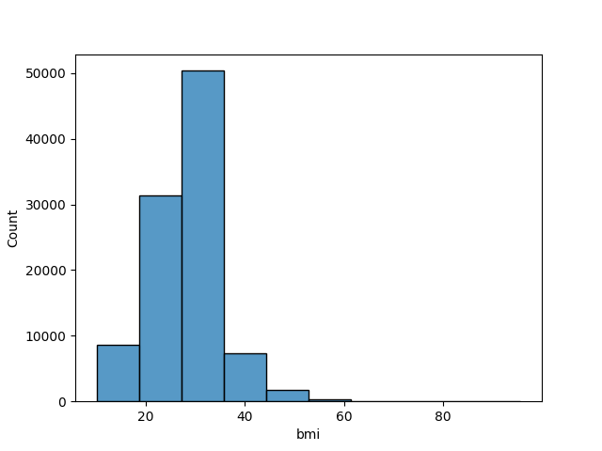
Graphs

